



Data Structures & Algorithm
LAB MANUAL

Disclaimer: The content is curated from online/offline resources and used for educational purpose only
Push and Pop Elements in Stack

Objective:
To understand stack operations (Push and Pop) using Python lists and simulate LIFO behavior.
Equipment Required:
- Computer with Python installed, text editor/IDE.

Prerequisites:
- Basic understanding of Python lists, functions, and stack data structure.
Problem Statement:
Write a Python program to implement push and pop operations on a stack.

Procedure:
- Initialize an empty list to represent the stack.
- Use append() to push elements onto the stack.
- Use pop() to remove the top element from the stack.
- Display the stack after each operation.

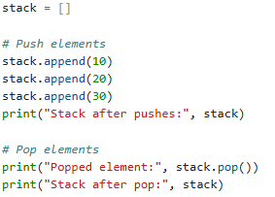
Output:
